Data Science and Business Intel Project

library(tidyverse)  
library(ggplot2)  
library(ggROC)  
library(cowplot)  
library(reshape2)  
library(car)  
library(caret)  
library(leaps)  
library(bestglm)  
library(plotly)  
library(webshot)  
library(DataExplorer)  
library(purrr)  
library(rpart)  
library(rpart.plot)  
library(randomForest)  
library(e1071)  
library(pROC)  
source("./[5]Script/Confusion_matrix.R")  
source("./[5]Script/cutoff.R")

# Read in raw data  
ds <- (read.csv("./[4]source/WA_Fn-UseC_-Telco-Customer-Churn.csv"))  
ds$SeniorCitizen <- as.factor(ds$SeniorCitizen)  
#####################################################################################  
# Metadata  
##################################################################################### Customer Churn: Whether customer has left within the last month   
# Service that each customer has signed up for  
# Demographic information   
# Customer Account Information  
#####################################################################################  
# Data Type:  
#####################################################################################  
# 16 Categorical Variables:  
# - 6 Binary Variables (Gender, Senior Citizen, Partner, Dependents, Phone Service, Paperless Billing)  
# - 9 3-Factor level Variable (Multiple Lines, Internet Service, Online Security, Online Backup, Device Protection, Tech Support, Streaming TV, Streaming Movies, Contract)  
# - 1 4-Factor level Variable (Payment Method)  
#####################################################################################  
# 3 Continious Variables:  
# - Tenure, Monthly Charge, Total Charge  
#####################################################################################  
# 1 Target Variables:  
# - Churn  
#####################################################################################

## Data Cleaning

# missing data analysis  
# 1) We first check if missing exist within our dataset  
print(paste0("The dataset contains missing data: ", any(is.na(ds))))

## [1] "The dataset contains missing data: TRUE"

if (any(is.na(ds)) == "TRUE"){  
 print(paste0("The total number of missing data(s) are: ", sum(is.na(ds))))  
 print(paste0("The variable(s) with missing data(s) are: ", colnames(ds)[colSums(is.na(ds))>0]))  
}

## [1] "The total number of missing data(s) are: 11"  
## [1] "The variable(s) with missing data(s) are: TotalCharges"

plot_missing(ds)

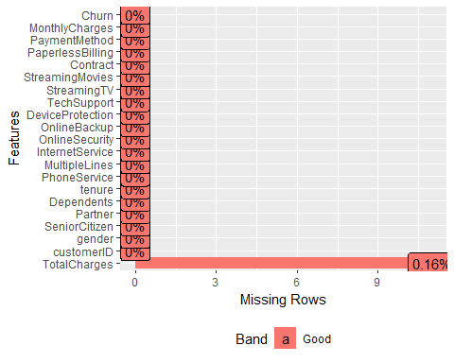

# 2) Filter the missing data into a its own dataset for further analysis  
df_na <- ds[rowSums(is.na(ds))>0,]  
df_na[c("gender","tenure","PhoneService","InternetService","Contract","MonthlyCharges","TotalCharges","Churn")]

## gender tenure PhoneService InternetService Contract MonthlyCharges  
## 489 Female 0 No DSL Two year 52.55  
## 754 Male 0 Yes No Two year 20.25  
## 937 Female 0 Yes DSL Two year 80.85  
## 1083 Male 0 Yes No Two year 25.75  
## 1341 Female 0 No DSL Two year 56.05  
## 3332 Male 0 Yes No Two year 19.85  
## 3827 Male 0 Yes No Two year 25.35  
## 4381 Female 0 Yes No Two year 20.00  
## 5219 Male 0 Yes No One year 19.70  
## 6671 Female 0 Yes DSL Two year 73.35  
## 6755 Male 0 Yes DSL Two year 61.90  
## TotalCharges Churn  
## 489 NA No  
## 754 NA No  
## 937 NA No  
## 1083 NA No  
## 1341 NA No  
## 3332 NA No  
## 3827 NA No  
## 4381 NA No  
## 5219 NA No  
## 6671 NA No  
## 6755 NA No

From the above missing data analysis, we are able to see out of the 7043 observation of 21 variables there are only 11 missing values and they are belong to the TOTAL CHARGES column(.16%), hence we are working with a pretty clean dataset.

An possible explaination for this mssing values is: (1) These customer never paid anything to the company (2) Tenure for all these customer are 0, thus meaning that this may be their first month with the company and thus the company hasn’t charged them.

For these 11 missing data, we can either: (1) Impute the total charge value (2) Set total charge value to be zero (3) Remove them from the data set

Since we have a relatively large dataset, and that none of the customer with missing value have churn, thus for convience of the analysis, we will drop the 11 observation with missing TOTAL CHARGE. ## Data Exploration

df_clean <- ds %>%   
 na.omit() %>%   
 select(-1)  
  
summary(df_clean)

## gender SeniorCitizen Partner Dependents tenure   
## Female:3483 0:5890 No :3639 No :4933 Min. : 1.00   
## Male :3549 1:1142 Yes:3393 Yes:2099 1st Qu.: 9.00   
## Median :29.00   
## Mean :32.42   
## 3rd Qu.:55.00   
## Max. :72.00   
## PhoneService MultipleLines InternetService  
## No : 680 No :3385 DSL :2416   
## Yes:6352 No phone service: 680 Fiber optic:3096   
## Yes :2967 No :1520   
##   
##   
##   
## OnlineSecurity OnlineBackup   
## No :3497 No :3087   
## No internet service:1520 No internet service:1520   
## Yes :2015 Yes :2425   
##   
##   
##   
## DeviceProtection TechSupport   
## No :3094 No :3472   
## No internet service:1520 No internet service:1520   
## Yes :2418 Yes :2040   
##   
##   
##   
## StreamingTV StreamingMovies  
## No :2809 No :2781   
## No internet service:1520 No internet service:1520   
## Yes :2703 Yes :2731   
##   
##   
##   
## Contract PaperlessBilling PaymentMethod   
## Month-to-month:3875 No :2864 Bank transfer (automatic):1542   
## One year :1472 Yes:4168 Credit card (automatic) :1521   
## Two year :1685 Electronic check :2365   
## Mailed check :1604   
##   
##   
## MonthlyCharges TotalCharges Churn   
## Min. : 18.25 Min. : 18.8 No :5163   
## 1st Qu.: 35.59 1st Qu.: 401.4 Yes:1869   
## Median : 70.35 Median :1397.5   
## Mean : 64.80 Mean :2283.3   
## 3rd Qu.: 89.86 3rd Qu.:3794.7   
## Max. :118.75 Max. :8684.8

# Binary variable distribution in Customer attribution  
ggplot(data = df_clean, aes(x = Churn, y = (..count..)/sum(..count..), fill = Churn))+  
 geom_bar()+  
 ggtitle("Customer Attribution")+  
 ylab("Percentage")

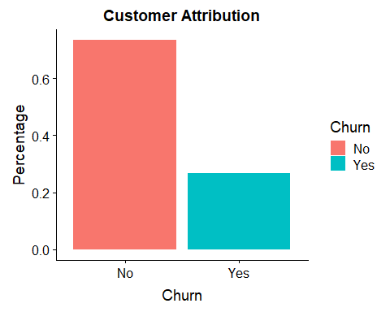 Of our dataset, 26% of the customer has left the platform within the past month

# Categorical Variable Analysis  
# Binary binary variables Analysis  
options(repr.plot.width = 12, repr.plot.height = 8)  
plot_grid(  
 ggplot(data = df_clean, aes(gender, fill = Churn))+geom_bar(position = "fill"),  
 ggplot(data = df_clean, aes(SeniorCitizen, fill = Churn))+geom_bar(position = "fill"),  
 ggplot(data = df_clean, aes(Partner, fill = Churn))+geom_bar(position = "fill"),  
 ggplot(data = df_clean, aes(Dependents, fill = Churn))+geom_bar(position = "fill"),  
 ggplot(data = df_clean, aes(PhoneService, fill = Churn))+geom_bar(position = "fill"),  
 ggplot(data = df_clean, aes(PaperlessBilling, fill = Churn))+geom_bar(position = "fill")  
)

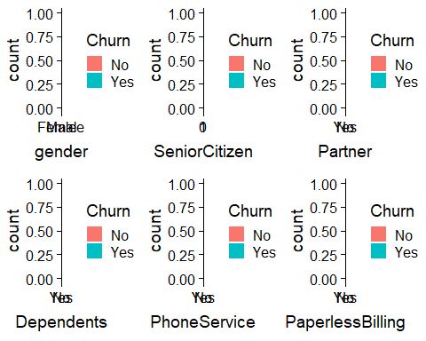

plot_grid(  
 ggplot(data = df_clean, aes(MultipleLines, fill = Churn))+geom_bar(position = "fill"),  
 ggplot(data = df_clean, aes(InternetService, fill = Churn))+geom_bar(position = "fill"),  
 ggplot(data = df_clean, aes(OnlineBackup, fill = Churn))+geom_bar(position = "fill"),  
 ggplot(data = df_clean, aes(OnlineSecurity, fill = Churn))+geom_bar(position = "fill"),  
 ggplot(data = df_clean, aes(DeviceProtection, fill = Churn))+geom_bar(position = "fill"),  
 ggplot(data = df_clean, aes(TechSupport, fill = Churn))+geom_bar(position = "fill"),  
 ggplot(data = df_clean, aes(StreamingTV, fill = Churn))+geom_bar(position = "fill"),  
 ggplot(data = df_clean, aes(StreamingMovies, fill = Churn))+geom_bar(position = "fill"),  
 ggplot(data = df_clean, aes(Contract, fill = Churn))+geom_bar(position = "fill")  
)

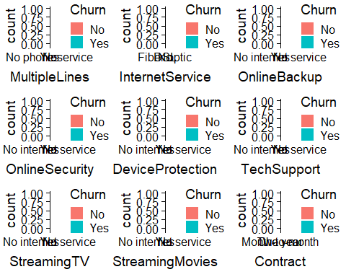

ggplot(data = df_clean, aes(x=PaymentMethod, fill=Churn))+  
 geom_bar(position = "fill")

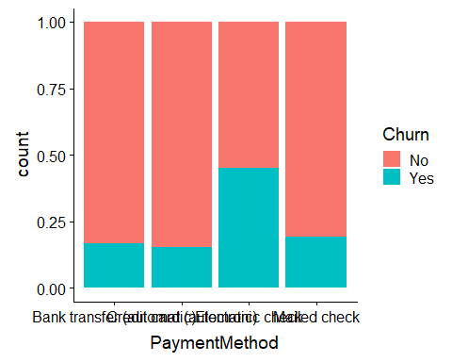 Some Trends - Senior Citizens churn percentage are higher - Customer with dependents or partners tend to have lower churn rate compared to counterparts - Customer with paperless billing have higher churn rate - Customer with Fiber Optic Internet Service have significant higher churn rate - Customer with No online security, or online backup or tech support have higher churn rate - Customer with monthly subscription are more likely to churn compared to customer with one- or two-year contract - Customer with Electronic Check payment method tend to leave our client more compared to other options.

# # Continous Variable Analysis  
# p <- plot_ly(df_clean,  
# x = ~MonthlyCharges,  
# y = ~TotalCharges,  
# z = ~tenure,  
# color = ~Churn,  
# marker = list(  
# size = 2)) %>%  
# add_markers() %>%  
# layout(scene = list(  
# xaxis = list(title = "Monthly Charges"),  
# yaxis = list(title = "Total Charges"),  
# zaxis = list(title = "Tenure")  
# ))  
# p

# Correlation matrix of continous variable analysis (thank you very much)  
scatterplotMatrix(~ tenure + MonthlyCharges + TotalCharges|Churn, data = df_clean, col = c("red","blue"))

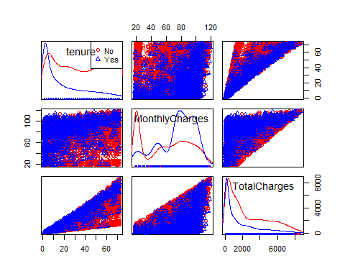 This appears to follow simple intuition, customer that are with the telecommunication firm for only a short period would in general have no loyalty compared to long time customer which are comfortable with the service provided and thus less willing to switch. Also, customer with higher monthly charges, will in general wish to reduce cost by seeking alternative service provider that may provide the same level of service for lower cost. From Figure 6, the scatter plots between continuous variables in general follows the trend described above and allow us to visually see if there are any obvious outliers which in this case seem to be none.

# Data Cleaning and Standardization  
df_clean2 <- df_clean %>%   
 mutate(MultipleLines=replace(MultipleLines,MultipleLines=="No phone service", "No")) %>%  
 mutate(OnlineSecurity=replace(OnlineSecurity,OnlineSecurity=="No internet service","No")) %>%   
 mutate(DeviceProtection=replace(DeviceProtection,DeviceProtection=="No internet service","No")) %>%   
 mutate(TechSupport=replace(TechSupport,TechSupport=="No internet service","No")) %>%   
 mutate(StreamingTV=replace(StreamingTV,StreamingTV=="No internet service","No")) %>%   
 mutate(StreamingMovies=replace(StreamingMovies,StreamingMovies=="No internet service","No")) %>%  
 mutate(OnlineBackup=replace(OnlineBackup,OnlineBackup=="No internet service","No")) %>%   
 mutate(tenure=scale(tenure)) %>%   
 mutate(MonthlyCharges=scale(MonthlyCharges)) %>%   
 mutate(TotalCharges=scale(TotalCharges))

# Split data into training and validation split  
set.seed(1994)  
training <- sample(2,nrow(df_clean2),replace=TRUE,prob=c(.8,.2))

# GLM Analysis  
# Still need to look at threshold analysis  
# Full GLM  
df_clean.fulllogit <- glm(Churn~.,   
 family = binomial,  
 data = df_clean2[training==1,])  
  
getinfo(df_clean.fulllogit,df_clean2)[c("confusion_matrix", "accuracy","sensitivity")]

## $confusion_matrix  
## predicted  
## observed 0 1  
## No 770 251  
## Yes 84 278  
##   
## $accuracy  
## [1] 0.757773  
##   
## $sensitivity  
## [1] 0.7679558

# Using Forward Approach to search for GLM model with lowest BIC   
  
# tmp.modelsearch <- bestglm(df_clean2[training==1,],IC = "BIC", family = binomial, method = "forward")  
  
  
# Takes a long while (>= 4 to 6 hours)  
# tmp.modelsearch$BestModels  
# tmp.modelsearch$BestModel  
  
# Best GLM Model  
df_clean.bestlogit <- glm(Churn~   
 SeniorCitizen +   
 tenure +   
 PhoneService +   
 InternetService +   
 OnlineSecurity +   
 Contract +   
 PaperlessBilling +   
 PaymentMethod +   
 TotalCharges,   
 family = binomial,  
 data = df_clean2[training==1,])  
  
summary(df_clean.bestlogit)

##   
## Call:  
## glm(formula = Churn ~ SeniorCitizen + tenure + PhoneService +   
## InternetService + OnlineSecurity + Contract + PaperlessBilling +   
## PaymentMethod + TotalCharges, family = binomial, data = df_clean2[training ==   
## 1, ])  
##   
## Deviance Residuals:   
## Min 1Q Median 3Q Max   
## -1.7854 -0.6901 -0.2898 0.7639 3.5287   
##   
## Coefficients:  
## Estimate Std. Error z value Pr(>|z|)  
## (Intercept) -1.15482 0.16519 -6.991 2.74e-12  
## SeniorCitizen1 0.36347 0.09087 4.000 6.33e-05  
## tenure -1.60719 0.16355 -9.827 < 2e-16  
## PhoneServiceYes -0.57854 0.14494 -3.991 6.57e-05  
## InternetServiceFiber optic 0.84120 0.10752 7.824 5.13e-15  
## InternetServiceNo -0.72024 0.14942 -4.820 1.43e-06  
## OnlineSecurityYes -0.49034 0.09413 -5.209 1.90e-07  
## ContractOne year -0.67067 0.11803 -5.682 1.33e-08  
## ContractTwo year -1.39744 0.19416 -7.198 6.13e-13  
## PaperlessBillingYes 0.36526 0.08213 4.447 8.71e-06  
## PaymentMethodCredit card (automatic) -0.08679 0.12595 -0.689 0.49081  
## PaymentMethodElectronic check 0.33125 0.10477 3.162 0.00157  
## PaymentMethodMailed check -0.17305 0.12792 -1.353 0.17612  
## TotalCharges 0.87972 0.15954 5.514 3.50e-08  
##   
## (Intercept) ***  
## SeniorCitizen1 ***  
## tenure ***  
## PhoneServiceYes ***  
## InternetServiceFiber optic ***  
## InternetServiceNo ***  
## OnlineSecurityYes ***  
## ContractOne year ***  
## ContractTwo year ***  
## PaperlessBillingYes ***  
## PaymentMethodCredit card (automatic)   
## PaymentMethodElectronic check **   
## PaymentMethodMailed check   
## TotalCharges ***  
## ---  
## Signif. codes: 0 '***' 0.001 '**' 0.01 '*' 0.05 '.' 0.1 ' ' 1  
##   
## (Dispersion parameter for binomial family taken to be 1)  
##   
## Null deviance: 6553.1 on 5648 degrees of freedom  
## Residual deviance: 4715.9 on 5635 degrees of freedom  
## AIC: 4743.9  
##   
## Number of Fisher Scoring iterations: 6

vif(df_clean.bestlogit)

## GVIF Df GVIF^(1/(2*Df))  
## SeniorCitizen 1.080908 1 1.039667  
## tenure 14.617958 1 3.823344  
## PhoneService 1.401480 1 1.183841  
## InternetService 2.402199 2 1.244951  
## OnlineSecurity 1.127523 1 1.061849  
## Contract 1.521245 2 1.110580  
## PaperlessBilling 1.113757 1 1.055347  
## PaymentMethod 1.343729 3 1.050474  
## TotalCharges 16.492869 1 4.061141

getinfo(df_clean.bestlogit,df_clean2)[c("confusion_matrix", "accuracy", "sensitivity")]

## $confusion_matrix  
## predicted  
## observed 0 1  
## No 773 248  
## Yes 82 280  
##   
## $accuracy  
## [1] 0.7613883  
##   
## $sensitivity  
## [1] 0.7734807

# Remove Total Charges due to high VIF value (>2, thus multi-colinearity effect)  
  
df_clean.bestlogit2 <- glm(Churn~   
 SeniorCitizen +   
 tenure +   
 PhoneService +   
 InternetService +   
 OnlineSecurity +   
 Contract +   
 PaperlessBilling +  
 PaymentMethod,   
 family = binomial,  
 data = df_clean2[training==1,])  
summary(df_clean.bestlogit2)

##   
## Call:  
## glm(formula = Churn ~ SeniorCitizen + tenure + PhoneService +   
## InternetService + OnlineSecurity + Contract + PaperlessBilling +   
## PaymentMethod, family = binomial, data = df_clean2[training ==   
## 1, ])  
##   
## Deviance Residuals:   
## Min 1Q Median 3Q Max   
## -1.8218 -0.6731 -0.3068 0.7653 3.1154   
##   
## Coefficients:  
## Estimate Std. Error z value Pr(>|z|)  
## (Intercept) -1.31487 0.15882 -8.279 < 2e-16  
## SeniorCitizen1 0.37046 0.09132 4.057 4.98e-05  
## tenure -0.78160 0.05612 -13.927 < 2e-16  
## PhoneServiceYes -0.40597 0.13731 -2.957 0.003111  
## InternetServiceFiber optic 1.07104 0.09861 10.862 < 2e-16  
## InternetServiceNo -0.85564 0.14626 -5.850 4.91e-09  
## OnlineSecurityYes -0.44134 0.09379 -4.706 2.53e-06  
## ContractOne year -0.63739 0.11659 -5.467 4.58e-08  
## ContractTwo year -1.30311 0.19059 -6.837 8.07e-12  
## PaperlessBillingYes 0.37475 0.08173 4.585 4.53e-06  
## PaymentMethodCredit card (automatic) -0.08768 0.12574 -0.697 0.485626  
## PaymentMethodElectronic check 0.35246 0.10472 3.366 0.000763  
## PaymentMethodMailed check -0.11915 0.12660 -0.941 0.346609  
##   
## (Intercept) ***  
## SeniorCitizen1 ***  
## tenure ***  
## PhoneServiceYes **   
## InternetServiceFiber optic ***  
## InternetServiceNo ***  
## OnlineSecurityYes ***  
## ContractOne year ***  
## ContractTwo year ***  
## PaperlessBillingYes ***  
## PaymentMethodCredit card (automatic)   
## PaymentMethodElectronic check ***  
## PaymentMethodMailed check   
## ---  
## Signif. codes: 0 '***' 0.001 '**' 0.01 '*' 0.05 '.' 0.1 ' ' 1  
##   
## (Dispersion parameter for binomial family taken to be 1)  
##   
## Null deviance: 6553.1 on 5648 degrees of freedom  
## Residual deviance: 4748.6 on 5636 degrees of freedom  
## AIC: 4774.6  
##   
## Number of Fisher Scoring iterations: 6

vif(df_clean.bestlogit2)

## GVIF Df GVIF^(1/(2*Df))  
## SeniorCitizen 1.081676 1 1.040037  
## tenure 1.662398 1 1.289340  
## PhoneService 1.358571 1 1.165577  
## InternetService 1.924459 2 1.177815  
## OnlineSecurity 1.113718 1 1.055328  
## Contract 1.481751 2 1.103300  
## PaperlessBilling 1.108524 1 1.052865  
## PaymentMethod 1.318029 3 1.047098

getinfo(df_clean.bestlogit2,df_clean2)[c("confusion_matrix", "accuracy", "sensitivity")]

## $confusion_matrix  
## predicted  
## observed 0 1  
## No 780 241  
## Yes 87 275  
##   
## $accuracy  
## [1] 0.7628344  
##   
## $sensitivity  
## [1] 0.7596685

# Decision Tree Analysis  
df_clean.fulltree <- rpart(Churn ~.,   
 data = df_clean2[training==1,], method = "class",  
 control = rpart.control(cp=0))   
  
getinfo(df_clean.fulltree,df_clean2)[c("confusion_matrix", "accuracy", "sensitivity")]

## $confusion_matrix  
## predicted  
## observed 0 1  
## No 811 210  
## Yes 127 235  
##   
## $accuracy  
## [1] 0.7563268  
##   
## $sensitivity  
## [1] 0.6491713

# Hyperparameter Tuning  
  
# plotcp(df_clean.fulltree)  
printcp(df_clean.fulltree)

##   
## Classification tree:  
## rpart(formula = Churn ~ ., data = df_clean2[training == 1, ],   
## method = "class", control = rpart.control(cp = 0))  
##   
## Variables actually used in tree construction:  
## [1] Contract Dependents DeviceProtection gender   
## [5] InternetService MonthlyCharges MultipleLines OnlineBackup   
## [9] OnlineSecurity PaperlessBilling Partner PaymentMethod   
## [13] PhoneService SeniorCitizen StreamingMovies StreamingTV   
## [17] TechSupport tenure TotalCharges   
##   
## Root node error: 1507/5649 = 0.26677  
##   
## n= 5649   
##   
## CP nsplit rel error xerror xstd  
## 1 0.07011723 0 1.00000 1.00000 0.022058  
## 2 0.01360319 3 0.78965 0.79761 0.020412  
## 3 0.00398142 5 0.76244 0.81287 0.020553  
## 4 0.00265428 10 0.73723 0.80027 0.020437  
## 5 0.00248839 18 0.71267 0.79429 0.020381  
## 6 0.00232250 22 0.70272 0.79429 0.020381  
## 7 0.00199071 31 0.67750 0.79496 0.020387  
## 8 0.00176952 32 0.67551 0.79695 0.020406  
## 9 0.00165893 49 0.63504 0.79695 0.020406  
## 10 0.00149303 61 0.61447 0.79628 0.020400  
## 11 0.00132714 65 0.60849 0.80226 0.020455  
## 12 0.00110595 75 0.59456 0.80624 0.020492  
## 13 0.00099536 81 0.58792 0.80823 0.020510  
## 14 0.00088476 91 0.57664 0.80956 0.020523  
## 15 0.00082946 107 0.55740 0.80956 0.020523  
## 16 0.00079628 113 0.55209 0.81221 0.020547  
## 17 0.00066357 120 0.54612 0.82681 0.020679  
## 18 0.00049768 126 0.54214 0.82681 0.020679  
## 19 0.00044238 137 0.53417 0.84472 0.020838  
## 20 0.00033179 140 0.53285 0.84472 0.020838  
## 21 0.00026543 142 0.53218 0.85468 0.020924  
## 22 0.00022119 147 0.53086 0.86662 0.021027  
## 23 0.00016589 150 0.53019 0.86662 0.021027  
## 24 0.00013271 159 0.52820 0.86662 0.021027  
## 25 0.00000000 164 0.52754 0.86662 0.021027

tmp <- df_clean.fulltree$cptable[which.min(df_clean.fulltree$cptable[,"xerror"]),]  
  
# Prune the tree  
df_clean.besttree <- prune(df_clean.fulltree,cp = 0.01)  
rpart.plot(df_clean.besttree)

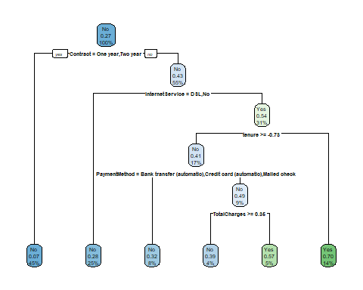

getinfo(df_clean.besttree,df_clean2)[c("confusion_matrix", "accuracy", "sensitivity")]

## $confusion_matrix  
## predicted  
## observed 0 1  
## No 844 177  
## Yes 144 218  
##   
## $accuracy  
## [1] 0.7678959  
##   
## $sensitivity  
## [1] 0.6022099

# Random Forest  
set.seed(1994)  
df_clean.rforest <- randomForest(Churn~.,  
 data = df_clean2[training==1,],  
 ntree=500, # dataset  
 cutoff=c(0.5,0.5),   
 mtry=2,  
 importance=TRUE)   
df_clean.rforest

##   
## Call:  
## randomForest(formula = Churn ~ ., data = df_clean2[training == 1, ], ntree = 500, cutoff = c(0.5, 0.5), mtry = 2, importance = TRUE)   
## Type of random forest: classification  
## Number of trees: 500  
## No. of variables tried at each split: 2  
##   
## OOB estimate of error rate: 20.46%  
## Confusion matrix:  
## No Yes class.error  
## No 3789 353 0.08522453  
## Yes 803 704 0.53284672

# Confusion Matrix Test  
getinfo(df_clean.rforest,df_clean2)[c("confusion_matrix", "accuracy", "sensitivity")]

## $confusion_matrix  
## predicted  
## observed 0 1  
## No 837 184  
## Yes 119 243  
##   
## $accuracy  
## [1] 0.7809111  
##   
## $sensitivity  
## [1] 0.6712707

# Hyperparameter Tuning  
set.seed(1994)  
rforest.tune <- tuneRF(x = df_clean2[training==1,]%>%select(-Churn),  
 y = df_clean2[training==1,]$Churn,mtryStart=2,  
 ntreeTry = 500)

## mtry = 2 OOB error = 20.38%   
## Searching left ...  
## mtry = 1 OOB error = 22.61%   
## -0.10947 0.05   
## Searching right ...  
## mtry = 4 OOB error = 20.62%   
## -0.01216334 0.05

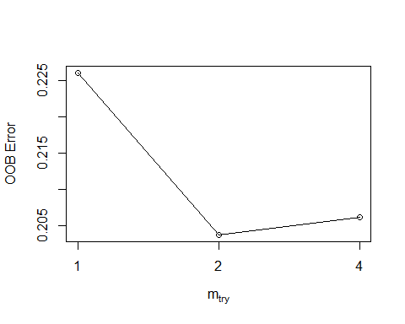

# Feature Importance Analysis  
# generateFilterValuesData(task, "randomForest.importance")  
df_clean2.feature <- randomForest(Churn~., data = df_clean2, importance = FALSE, ntree = 500, mtry = 2, do.trace=FALSE)  
  
varImpPlot(df_clean2.feature)

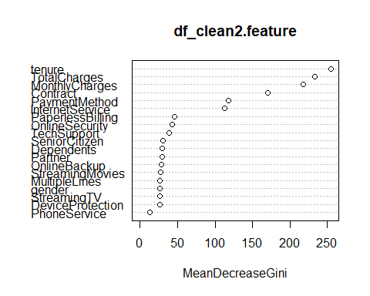

# SVM  
df_clean.svm <- svm(Churn~.,  
 data = df_clean2[training==1,],  
 kernel = "linear",  
 cost = 0.01,  
 proability = TRUE)  
  
getinfo(df_clean.svm,df_clean2)[c("confusion_matrix", "accuracy", "sensitivity")]

## $confusion_matrix  
## predicted  
## observed No Yes  
## No 919 102  
## Yes 179 183  
##   
## $accuracy  
## [1] 0.7968185  
##   
## $sensitivity  
## [1] 0.5055249

# Hyperparameter Tuning  
svm.tune <- tune(svm,  
 Churn~.,  
 data = df_clean2[training==1,],  
 kernel = "linear",  
 ranges = list(cost = 10^(-5:0)))  
   
print(svm.tune)

##   
## Parameter tuning of 'svm':  
##   
## - sampling method: 10-fold cross validation   
##   
## - best parameters:  
## cost  
## 1  
##   
## - best performance: 0.1993228

svm.tune$best.model

##   
## Call:  
## best.tune(method = svm, train.x = Churn ~ ., data = df_clean2[training ==   
## 1, ], ranges = list(cost = 10^(-5:0)), kernel = "linear")  
##   
##   
## Parameters:  
## SVM-Type: C-classification   
## SVM-Kernel: linear   
## cost: 1   
## gamma: 0.03225806   
##   
## Number of Support Vectors: 2589

df_clean.bestsvm <- svm(Churn~.,  
 data = df_clean2[training==1,],  
 kernel = "linear",  
 cost = 0.1,  
 probaility = TRUE)  
summary(df_clean.bestsvm)

##   
## Call:  
## svm(formula = Churn ~ ., data = df_clean2[training == 1, ], kernel = "linear",   
## cost = 0.1, probaility = TRUE)  
##   
##   
## Parameters:  
## SVM-Type: C-classification   
## SVM-Kernel: linear   
## cost: 0.1   
## gamma: 0.03225806   
##   
## Number of Support Vectors: 2608  
##   
## ( 1308 1300 )  
##   
##   
## Number of Classes: 2   
##   
## Levels:   
## No Yes

getinfo(df_clean.bestsvm,df_clean2)[c("confusion_matrix", "accuracy", "sensitivity")]

## $confusion_matrix  
## predicted  
## observed No Yes  
## No 915 106  
## Yes 178 184  
##   
## $accuracy  
## [1] 0.7946493  
##   
## $sensitivity  
## [1] 0.5082873

# Performance evaluation - Learning Curves and Fitted Graphs  
# AUC Curve  
# First assemble the probability matrix  
prob_matrix <- data.frame(  
 "logit" = predict(df_clean.bestlogit2,df_clean2[training==2,],type = "response"),  
 "d_tree" = predict(df_clean.besttree, df_clean2[training==2,],type="prob")[,2],  
 "r_forest" = predict(df_clean.rforest, df_clean2[training==2,], type = "prob")[,2],  
 "svm" = as.numeric(attr(predict(df_clean.bestsvm, df_clean2[training==2,], decision.values = TRUE),"decision.values"))  
 )  
# Create the ROC Varible  
  
logit.roc <- roc(df_clean2$Churn[training==2],prob_matrix$logit)  
d_tree.roc <- roc(df_clean2$Churn[training==2],prob_matrix$d_tree)  
r_forest.roc <- roc(df_clean2$Churn[training==2],prob_matrix$r_forest)  
svm.roc <- roc(df_clean2$Churn[training==2],prob_matrix$svm)  
  
ggroc(list(logit=logit.roc,decision.tree=d_tree.roc,random.forest=r_forest.roc,svm=svm.roc),legacy.axes = FALSE)

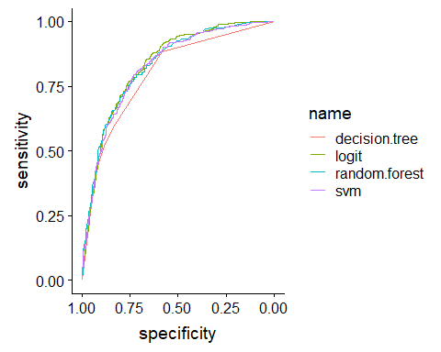

tmp4 <- c(logit.roc$auc,d_tree.roc$auc,r_forest.roc$auc,svm.roc$auc)  
  
tmp5 <- data.frame(  
 "AUC" = tmp4  
)  
row.names(tmp5)<- c("Logit","Decision Tree", "Random Forest","SVM")  
  
tmp5

## AUC  
## Logit 0.8358193  
## Decision Tree 0.7981680  
## Random Forest 0.8314863  
## SVM 0.8270775

A small discussion about cutoff point:

As we are attempting to identify customer that are going to churn, we thus need to focus on sensitivity metric compared to accuracy. As it is comparitively more expensive to acquire customer than retain customer, thus we are not as concern with false positive, but rather concerned with false negative. We would idealy like a model that is able to successful target all customer that are going to churn, and it should matter less if we have a higher number of false postive to us a telcommunication company. Thus we should have a lower threshold value than 0.5, though the actual value often require domain knowledge which we lack, thus we are going to use a more objective method to set out threshold value.

# Lets use logistic regression as it has the largest AUC out of all three method  
  
# output <- matrix(0,100,3)  
# x_axis <- seq(0.01,0.8,length=100)  
#   
# for (i in 1:100)  
# {  
# output[i,]=threshold(x_axis[i])  
# }  
#   
# plot(x_axis,output[,1], type = "l", col = "darkgreen", xlab = "Threshold Value", ylab = "Values")  
# lines(x_axis,output[,2],col = "red")  
# lines(x_axis,output[,3], col = "blue")  
# legend("bottom",col=c(2,"darkgreen",4,"darkred"),text.font =3,inset = 0.02,  
# box.lty=0,cex = 0.8,  
# lwd=c(2,2,2,2),c("Specificity","Senitivity","Accuracy"))  
#   
#   
# x_axis[which(abs(output[,1]-output[,2])<0.01)]